**Prompt used for generating software requirements from PRS 01 & PRS-02**

Give me the sw requirements for the product requirement "The user shall be able to launch XXX Connect app and connect to a surgical microscope available in the Wi-Fi network," this is for building a mobile iOS and Android application

Software Requirements for "XXX Connect" App

**Product Requirement:**

**"The user shall be able to launch XXX Connect app and connect to a surgical microscope available in the Wi-Fi network."**

Software Requirements:

**Application Launch**

**Requirement ID: SR-001**

**Description: The application shall be available for download and installation on both iOS and Android platforms.**

Acceptance Criteria:

The app must be listed on the Apple App Store and Google Play Store.

The app must launch without errors on both iOS and Android devices.

**User Interface for Microscope Discovery**

**Requirement ID: SR-002**

**Description: The application shall provide a user interface to discover surgical microscopes on the Wi-Fi network.**

Acceptance Criteria:

The app must display a "Scan for Devices" button on the main screen.

The app must show a loading indicator while scanning for devices.

The app must display a list of discovered microscopes with their names and statuses.

Wi-Fi Network Scanning

**Requirement ID: SR-003**

**Description: The application shall scan the Wi-Fi network for available surgical microscopes.**

Acceptance Criteria:

The app must initiate a network scan when the user taps the "Scan for Devices" button.

The app must identify and list all available surgical microscopes on the same Wi-Fi network.

The app must handle and display errors if no microscopes are found or if the scan fails.

Microscope Selection and Connection

**Requirement ID: SR-004**

**Description: The application shall allow the user to select a microscope from the list and establish a connection.**

Acceptance Criteria:

The app must allow the user to tap on a listed microscope to initiate a connection.

The app must display a connection status indicator (e.g., connecting, connected, failed).

The app must notify the user upon successful connection or display an error message if the connection fails.

**Connection Management**

**Requirement ID: SR-005**

**Description: The application shall manage the connection to the microscope, including handling connection errors and disconnections**.

Acceptance Criteria:

The app must maintain the connection to the microscope once established.

The app must detect and notify the user if the connection is lost.

The app must provide an option to retry the connection or disconnect manually.

**Security and Permissions**

**Requirement ID: SR-006**

**Description: The application shall request necessary permissions and ensure secure communication with the microscope.**

Acceptance Criteria:

The app must request Wi-Fi and network permissions during installation or first launch.

The app must use secure protocols (e.g., HTTPS, WPA2) for communication with the microscope.

The app must handle permission denial gracefully and inform the user of required permissions.

**Cross-Platform Compatibility**

**Requirement ID: SR-007**

**Description: The application shall be compatible with both iOS and Android platforms.**

Acceptance Criteria:

The app must function correctly on the latest versions of iOS and Android.

The app must support a range of device screen sizes and orientations.

The app must pass platform-specific guidelines and requirements for both iOS and Android.

**User Feedback and Notifications**

**Requirement ID: SR-008**

**Description: The application shall provide feedback and notifications to the user regarding the connection status and any errors.**

Acceptance Criteria:

The app must display notifications for successful connections, disconnections, and errors.

The app must provide clear and concise error messages with possible actions for the user.

The app must use standard notification mechanisms for both iOS and Android platforms.

These software requirements outline the necessary features and functionalities to meet the product requirement of allowing users to launch the "XXX Connect" app and connect to a surgical microscope available on the Wi-Fi network.

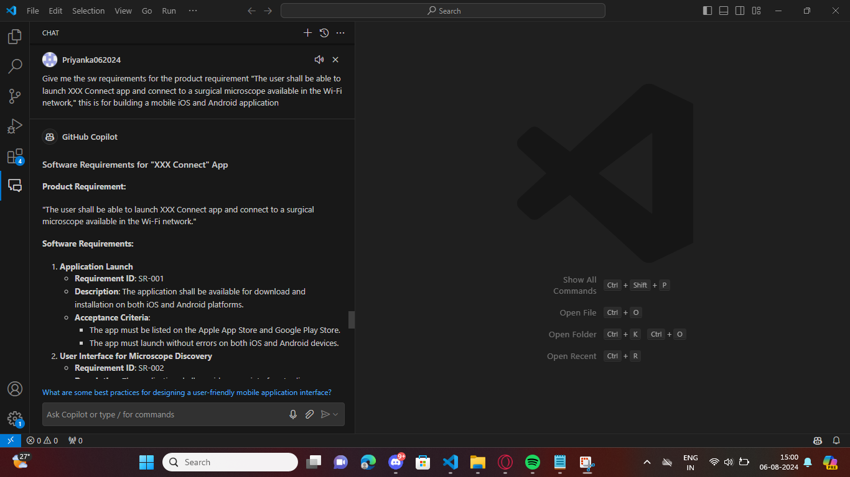

**Prompt used for generating software requirements from PRS 03**

What are the sw requirements for the product requirement "The user shall be able to start the live streaming from the connected surgical microscope via XXX Connect app," this is for building a mobile iOS and android application:  
  
**Software Requirements for Live Streaming from Surgical Microscope**Product Requirement:  
"The user shall be able to start the live streaming from the connected surgical microscope via XXX Connect app."  
  
Software Requirements:  
**Live Streaming Interface  
Requirement ID: SR-008  
Description: The application shall provide a user interface to start and stop live streaming from the connected surgical microscope.**  
Acceptance Criteria:  
The app must display a "Start Live Stream" button when a microscope is connected.  
The app must display a "Stop Live Stream" button when streaming is active.  
The app must show the live video feed from the microscope when streaming is active.  
**Live Streaming Initialization  
Requirement ID: SR-009  
Description: The application shall initialize the live streaming session when the user taps the "Start Live Stream" button.**  
Acceptance Criteria:  
The app must establish a connection to the microscope's streaming service.  
The app must handle and display errors if the streaming initialization fails.  
The app must notify the user when the live streaming session has started successfully.  
**Live Streaming Termination  
  
Requirement ID: SR-010  
Description: The application shall terminate the live streaming session when the user taps the "Stop Live Stream" button.**Acceptance Criteria:  
The app must stop the video feed from the microscope.  
The app must release any resources associated with the live streaming session.  
The app must notify the user when the live streaming session has stopped successfully.  
**Streaming Quality and Performance  
  
Requirement ID: SR-011  
Description: The application shall ensure high-quality and low-latency live streaming from the microscope.**  
Acceptance Criteria:  
The app must support high-definition video streaming.  
The app must maintain a low-latency connection to ensure real-time video feed.  
The app must handle network fluctuations and adjust the streaming quality accordingly.  
**User Feedback and Notifications**  
  
**Requirement ID: SR-012  
Description: The application shall provide feedback and notifications to the user regarding the live streaming status and any errors.**  
Acceptance Criteria:  
The app must display notifications for successful start and stop of live streaming.  
The app must provide clear and concise error messages with possible actions for the user.  
The app must use standard notification mechanisms for both iOS and Android platforms.  
**Security and Permissions  
  
Requirement ID: SR-013  
Description: The application shall request necessary permissions and ensure secure communication during live streaming.**  
Acceptance Criteria:  
The app must request camera and microphone permissions during installation or first launch.  
The app must use secure protocols (e.g., HTTPS, WPA2) for live streaming communication.  
The app must handle permission denial gracefully and inform the user of required permissions.  
**Cross-Platform Compatibility  
  
Requirement ID: SR-014  
Description: The application shall be compatible with both iOS and Android platforms for live streaming.**  
Acceptance Criteria:  
The app must function correctly on the latest versions of iOS and Android.  
The app must support a range of device screen sizes and orientations.  
The app must pass platform-specific guidelines and requirements for both iOS and Android.  
**Connection Management  
  
Requirement ID: SR-015  
Description: The application shall manage the connection to the microscope during live streaming, including handling connection errors and disconnections.**  
Acceptance Criteria:  
The app must maintain the connection to the microscope during live streaming.  
The app must detect and notify the user if the connection is lost during streaming.  
The app must provide an option to retry the connection or stop streaming if the connection is lost.

These software requirements outline the necessary features and functionalities to meet the product requirement of allowing users to start live streaming from the connected surgical microscope via the "XXX Connect" app on both iOS and Android platforms.

**Prompt used for generating software requirements from PRS 04**

what are the software requirements for the product requirement " the user should be able to capture images and record videos from the live stream of the connected surgical microscope" this is for building an ios and android mobile application

**Software Requirements for Capturing Images and Recording Videos**

Product Requirement:

"The user should be able to capture images and record videos from the live stream of the connected surgical microscope."

Software Requirements:

**1. Capture Image from Live Stream**

**-Requirement ID: SR-016**

**-Description: The application shall allow the user to capture images from the live stream of the connected surgical microscope.**

- Acceptance Criteria**:

- The app must provide a "Capture Image" button during live streaming.

- The app must save the captured image to the device's gallery or a specified directory.

- The app must notify the user when the image is successfully captured and saved.

- The app must handle and display errors if the image capture fails.

**2. **Record Video from Live Stream\*\***

**- **Requirement ID**: SR-017**

**- **Description**: The application shall allow the user to record videos from the live stream of the connected surgical microscope.**

- **Acceptance Criteria**:

- The app must provide "Start Recording" and "Stop Recording" buttons during live streaming.

- The app must save the recorded video to the device's gallery or a specified directory.

- The app must notify the user when the video recording starts and stops successfully.

- The app must handle and display errors if the video recording fails.

**3. **Image and Video Quality\*\***

**- **Requirement ID**: SR-018**

**- **Description**: The application shall ensure high-quality images and videos are captured and recorded from the live stream.**

- **Acceptance Criteria**:

- The app must capture images in high resolution.

- The app must record videos in high definition.

- The app must allow the user to configure the quality settings for images and videos.

**4. **Storage Management\*\***

**- **Requirement ID**: SR-019**

**- **Description**: The application shall manage the storage of captured images and recorded videos efficiently.**

- **Acceptance Criteria**:

- The app must check for available storage space before capturing images or recording videos.

- The app must notify the user if there is insufficient storage space.

- The app must provide options to manage and delete captured images and recorded videos.

**5. **User Feedback and Notifications\*\***

**- **Requirement ID**: SR-020**

**- **Description**: The application shall provide feedback and notifications to the user regarding the status of image capture and video recording**.

- **Acceptance Criteria**:

- The app must display notifications for successful image capture and video recording.

- The app must provide clear and concise error messages with possible actions for the user.

- The app must use standard notification mechanisms for both iOS and Android platforms.

**6. **Security and Permissions\*\***

**- **Requirement ID**: SR-021**

**- **Description**: The application shall request necessary permissions and ensure secure handling of captured images and recorded videos.**

- **Acceptance Criteria**:

- The app must request storage permissions during installation or first launch.

- The app must handle permission denial gracefully and inform the user of required permissions.

- The app must ensure that captured images and recorded videos are stored securely.

**7. **Cross-Platform Compatibility\*\***

**- **Requirement ID**: SR-022**

**- **Description**: The application shall be compatible with both iOS and Android platforms for capturing images and recording videos.**

- **Acceptance Criteria**:

- The app must function correctly on the latest versions of iOS and Android.

- The app must support a range of device screen sizes and orientations.

- The app must pass platform-specific guidelines and requirements for both iOS and Android.

**8. **Connection Management\*\***

**- **Requirement ID**: SR-023**

**- **Description**: The application shall manage the connection to the microscope during image capture and video recording.**

- **Acceptance Criteria**:

- The app must maintain the connection to the microscope during image capture and video recording.

- The app must detect and notify the user if the connection is lost during these operations.

- The app must provide an option to retry the connection or stop the operation if the connection is lost.

These software requirements outline the necessary features and functionalities to meet the product requirement of allowing users to capture images and record videos from the live stream of the connected surgical microscope via the mobile application on both iOS and Android platforms.

**Prompt used for generating software requirements from PRS 05**

what are the software requirements for a product requirement which says" The user shall be able to login to the cloud services with XXX Connect app" this is for building an ios and android mobile application  
  
**Software Requirements for User Login to Cloud Services**  
Product Requirement:  
"The user shall be able to login to the cloud services with XXX Connect app."  
  
Software Requirements:  
**User Authentication  
  
Requirement ID: SR-001  
Description: The application shall allow users to authenticate using their credentials to access cloud services.**Acceptance Criteria:  
The app must provide a login screen with fields for username and password.  
The app must validate the entered credentials against the cloud service.  
The app must display an error message if the credentials are invalid.  
The app must allow users to log in successfully if the credentials are valid.  
**Third-Party Authentication  
  
Requirement ID: SR-002  
Description: The application shall support third-party authentication providers (e.g., Google, Facebook, Apple).**  
Acceptance Criteria:  
The app must provide options to log in using third-party authentication providers.  
The app must handle the authentication flow for each provider.  
The app must retrieve and store the necessary authentication tokens.  
**Secure Communication  
  
Requirement ID: SR-003  
Description: The application shall ensure secure communication between the app and cloud services.**Acceptance Criteria:  
The app must use HTTPS for all communication with the cloud services.  
The app must handle SSL/TLS certificates properly.  
The app must encrypt sensitive data during transmission.  
**Session Management  
  
Requirement ID: SR-004  
Description: The application shall manage user sessions securely.**Acceptance Criteria:  
The app must store session tokens securely on the device.  
The app must handle session expiration and prompt the user to re-login if necessary.  
The app must provide a logout option to terminate the session.  
Error Handling and Notifications  
  
**Requirement ID: SR-005  
Description: The application shall handle errors and provide appropriate notifications to the user.**Acceptance Criteria:  
The app must display error messages for failed login attempts.  
The app must provide clear instructions for resolving login issues.  
The app must handle network errors gracefully and inform the user.  
**User Interface  
  
Requirement ID: SR-006  
Description: The application shall provide a user-friendly interface for the login process.**Acceptance Criteria:  
The app must have a clean and intuitive login screen.  
The app must provide visual feedback during the login process (e.g., loading indicators).  
The app must support accessibility features (e.g., screen readers, high contrast).  
**Cross-Platform Compatibility  
  
Requirement ID: SR-007  
Description: The application shall be compatible with both iOS and Android platforms.**Acceptance Criteria:  
The app must function correctly on the latest versions of iOS and Android.  
The app must support a range of device screen sizes and orientations.  
The app must pass platform-specific guidelines and requirements for both iOS and Android.  
**Security and Permissions  
  
Requirement ID: SR-008  
Description: The application shall request necessary permissions and ensure secure handling of user credentials.**Acceptance Criteria:  
The app must request permissions for internet access.  
The app must handle permission denial gracefully and inform the user of required permissions.  
The app must ensure that user credentials are stored securely.

These software requirements outline the necessary features and functionalities to meet the product requirement of allowing users to log in to cloud services using the XXX Connect app on both iOS and Android platforms.

